Low Fidelity designs

The preceding image depicts a brief mock-up that was created to demonstrate the foundation for the high-fidelity design.

The image depicts the first-person perspective (POV) of what the user will see upon entering the virtual reality environment. This is where they will be introduced to the four distinct structures, each of which contains a portal leading to the videos and images.

The image below illustrates what the user will see as they approach a building; however, in this example, only site 1 is displayed because the others are similar. The user can now access the videos and images associated with the site via the portal.

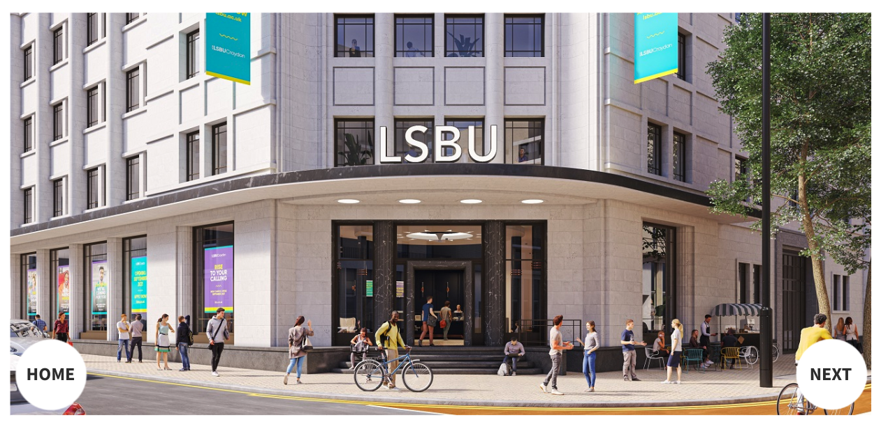

This image depicts the user's view upon entering the portal. As depicted in the figure, users will be greeted by a 360-degree video of the site. Here the user can choose to return to the homepage or select the "next" button to view additional 360 images.

**Flowcharts for ExploreX**

The two flowcharts highlighted in the figures above, depicts how the user will interact with the website to access the VR environment, as well as the decisions that may be taken to access a specific site in the VR space.

The final two figures illustrate four subroutines that refer to each site and demonstrate how the user interacts with the environment to display a 360 video and images.

**High Fidelity**

The high quality design shown above is the basis for the final product. As stated above, stars were utilised as the website's the background since the project's name is "ExploreX" and the background fit the term nicely. Additionally, the colour used for the button was used as it contrasts well with the design assigned to the website.

The VR environment home page depicted above resembles low-fidelity environments in that it consists of four distinct sites. Each box contains pillars that were constructed in 3D using shadows to provide more depth. In addition, the platform and portal have been designed to appear to be floating. The colours used for all objects, walls, and floors were complementary with each other, and the proportions and layout are more accurate compared to low fidelity.

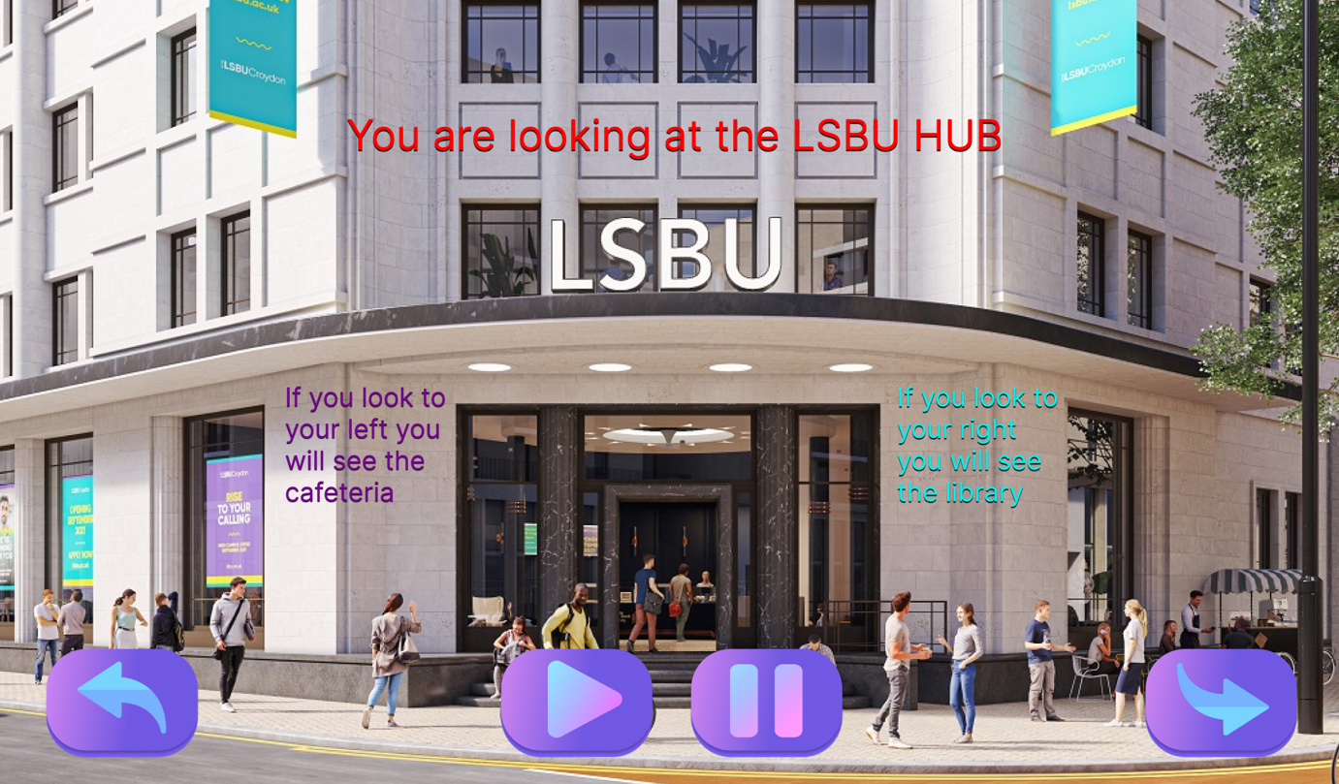

This image is likewise comparable to low fidelity in that it has similar functionalities such as play and go back. However, with the high fidelity design, we opted to provide extra functionality that allows the user to play and pause the video. The text was carefully positioned and coloured to engage the audience with the video and make it easy for them to navigate. The back button will take the user back to the VR home page; however, the next button will take the user to the 360 images.

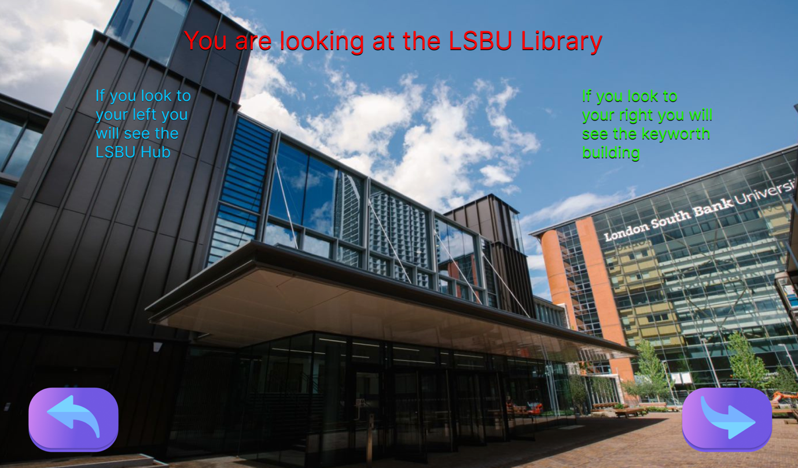

For the 360 images, the colour and position of the text was just as well placed in the 360 video. As this is an image, the play and pause buttons were neglected, and the colour used for the buttons was vibrant, so they are easily visible and do not clash with the image's colours. When the user observes the fourth and final image, clicking the next button will return them to the VR homepage.